**Department of Electrical Engineering and   
Computer Science**

**Faculty Member:** Dr. Rehan Ahmed  **Dated:** 1/03/2023

**Semester:**  6th **Section:** BEE 12C

**EE-421:** **Digital System Design**

**Lab 4: Latches, Flip-flops, and Registers**

Group Members

|  |  |  |  |  |  |  |
| --- | --- | --- | --- | --- | --- | --- |
|  |  | **PLO4-CLO3** | | **PLO5 -CLO4** | **PLO8 -CLO5** | **PLO9 -CLO6** |
| **Name** | **Reg. No** | **Viva / Quiz / Lab Performance** | **Analysis of data in Lab Report** | **Modern Tool Usage** | **Ethics and Safety** | **Individual and Teamwork** |
|  |  | **5 Marks** | **5 Marks** | **5 Marks** | **5 Marks** | **5 Marks** |
| Danial Ahmad | 331388 |  |  |  |  |  |
| Muhammad Umer | 345834 |  |  |  |  |  |
| Tariq Umar | 334943 |  |  |  |  |  |

**Table of Contents**

2 Latches, Flip-flops, and Registers 3

2.1 Objectives 3

2.2 Introduction 3

2.3 Software 3

3 Lab Procedure 4

3.1 Part I 4

3.2 Part II 5

3.3 Part III 7

3.4 Part IV 8

3.5 Part V 10

4 Conclusion 13

# Latches, Flip-flops, and Registers

## Objectives

The objective of this laboratory exercise is to investigate the behavior and functionality of latches, flip-flops, and registers. The experiment aims to provide a deeper understanding of the fundamental principles behind these digital circuits and their applications in digital systems.

## Introduction

Digital circuits play a crucial role in modern electronics, powering everything from computers to smartphones to automobiles. These circuits are constructed from basic building blocks, such as latches, flip-flops, and registers, which are essential components for the storage and manipulation of digital data.

Latches are simple storage devices that can hold a single bit of data, while flip-flops are more complex devices that can store a single bit of data and provide a clocked mechanism for input and output. Registers, on the other hand, are arrays of flip-flops that can store larger amounts of data. These digital circuits are widely used in a variety of applications, including memory, counters, and state machines. By understanding how these components work and how they can be combined, we can design more complex digital systems that can perform sophisticated operations.

## Software

Quartus Prime is a comprehensive design software developed by Intel Corporation for designing digital circuits using Field-Programmable Gate Arrays (FPGAs). It is a leading software platform in the field of digital design, offering a range of advanced tools and features that enable users to easily create, debug, and verify complex digital circuits. With Quartus Prime, users can benefit from a streamlined design flow that facilitates the creation of digital circuits from concept to implementation. It provides an intuitive graphical user interface that allows users to easily design, test, and debug their circuits. Additionally, Quartus Prime supports a variety of popular programming languages, making it a versatile platform for digital designers of all levels.

# Lab Procedure

## Part I

1. Create a Quartus project for the RS latch circuit as follows:
2. Create a new Quartus project for your DE-series board.
3. Generate a Verilog file for the RS latch. Use the code in either Figure 2 or Figure 3 (both versions of the 2 codes should produce the same circuit) and include it in the project.

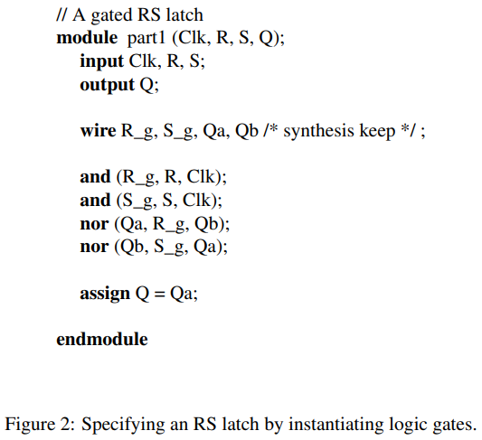 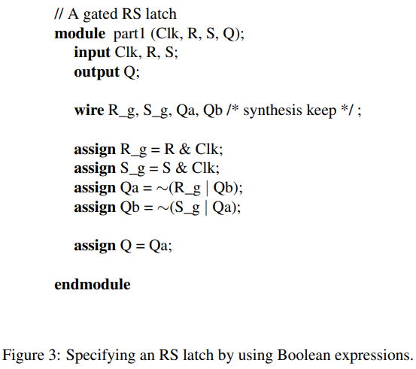

1. Compile the code. Use the Quartus RTL Viewer tool to examine the gate-level circuit produced from the code and use the Technology Map Viewer tool to verify that the latch is implemented as shown in Figure 4b.
2. Simulate the behavior of your Verilog code by using the simulation feature provided in the Quartus software.

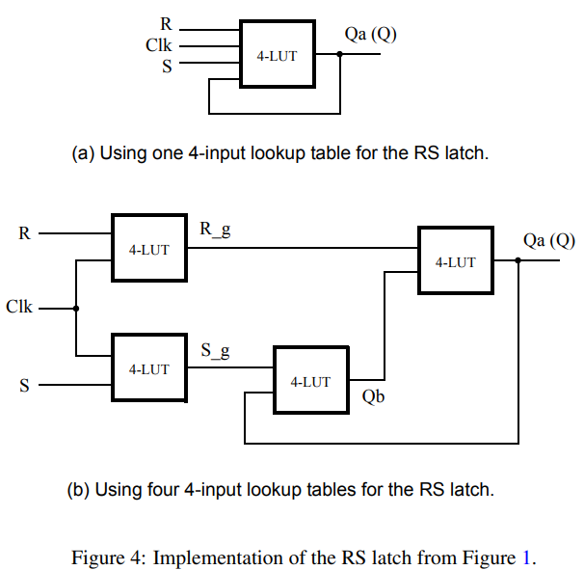

module *task_1* (

*input*  clk,

*input*  R,

*input*  S,

*output* Q

);

   wire R_g, S_g, Qa, Qb  /* synthesis keep */;

   assign R_g = R & clk;

   assign S_g = S & clk;

   assign Qa  = ~(R_g | Qb);

   assign Qb  = ~(S_g | Qa);

   assign Q   = Qa;

endmodule

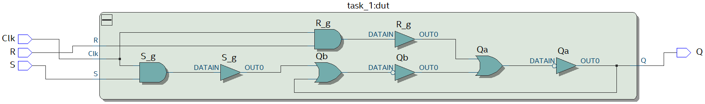



## Part II

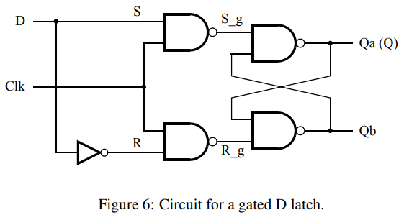

Perform the following steps:

1. Create a new Quartus project. Generate a Verilog file using the style of code in Figure 3 for the gated D latch. Use the /* synthesis keep */ directive to ensure that separate logic elements are used to implement the signals R, S_g, R_g, Qa, and Qb.
2. Compile your project and then use the Technology Map Viewer tool to examine the implemented circuit.
3. Verify that the latch works properly for all input conditions by using functional simulation. Examine the timing characteristics of the circuit by using timing simulation.
4. Create a new Quartus project which will be used for implementation of the gated D latch on your DE-series board. This project should consist of a top-level module that contains the appropriate input and output ports (pins) for your board. Instantiate your latch in this top-level module. Use switch SW0 to drive the D input of the latch and use SW1 as the Clk input. Connect the Q output to LEDR0.
5. Include the required pin assignments and then compile your project and download the compiled circuit onto your DE-series board. 6. Test the functionality of your circuit by toggling the D and Clk switches and observing the Q output.

module *task_2* (

*input*  Clk,

*input*  D,

*output* Q

);

   wire R, S, R_g, S_g, Q_a, Q_b  /* synthesis keep */;

   assign R   = ~D;

   assign S   = D;

   assign R_g = ~(R & Clk);

   assign S_g = ~(S & Clk);

   assign Q_a = ~(S_g & Q_b);

   assign Q_b = ~(R_g & Q_a);

   assign Q   = Q_a;

endmodule

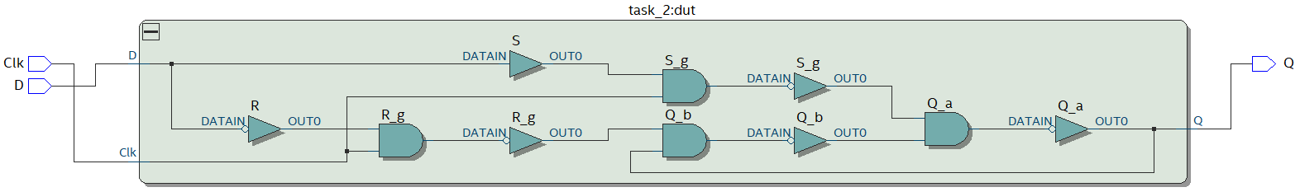



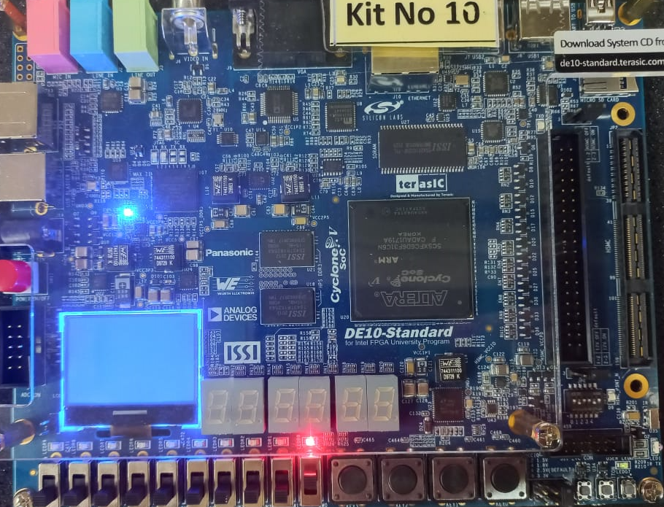 

## Part III

Perform the following:

1. Create a new Quartus project. Generate a Verilog file that instantiates two copies of your gated D latch module from Part II to implement the master-slave flip-flop.
2. Include in your project the appropriate input and output ports for your DE-series board. Use switch SW0 to drive the D input of the flip-flop and use SW1 as the Clock input. Connect the Q output to LEDR0.
3. Include the required pin assignments and then compile your project.
4. Use the Technology Map Viewer to examine the D flip-flop circuit and use simulation to verify its correct operation.
5. Download the circuit onto your DE-series board and test its functionality by toggling the D and Clock switches and observing the Q output.

module *task_3* (

*input*  clk,

*input*  D,

*output* Q

);

   wire Q_m, Q_s, inv_clk  /* synthesis keep */;

   assign inv_clk = ~clk;

*task_2* master_latch (

       .clk(inv_clk),

       .D  (D),

       .Q  (Q_m)

   );

*task_2* slave_latch (

       .clk(clk),

       .D  (Q_m),

       .Q  (Q_s)

   );

   assign Q = Q_s;

endmodule

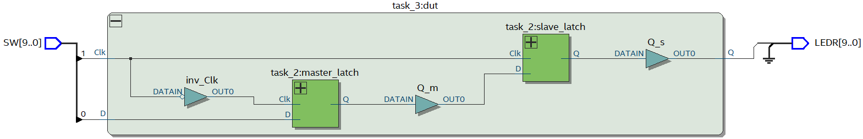



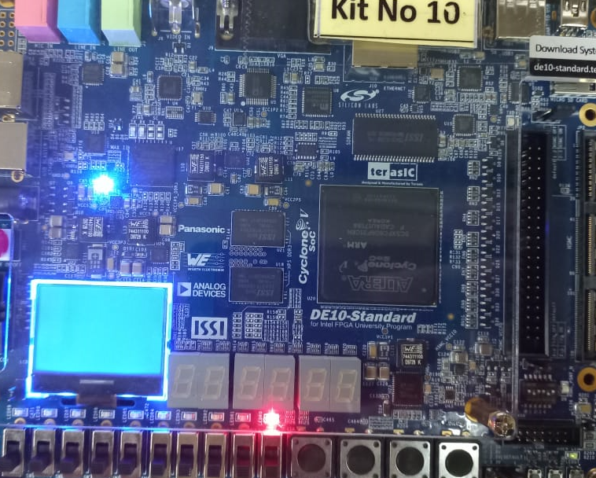 

## Part IV

Implement and simulate this circuit using the Quartus software as follows:

1. Create a new Quartus project.
2. Write a Verilog file that instantiates the three storage elements. For this part you should no longer use the /* synthesis keep */ directive from Parts I to III. Figure 9 gives a behavioral style of Verilog code that specifies the gated D latch in Figure 6.
3. Compile your code and use the Technology Map Viewer to examine the implemented circuit. Verify that the latch uses one lookup table and that the flip-flops are implemented using the flip-flops provided in the target FPGA.
4. Create a Vector Waveform File (.vwf) that specifies the inputs and outputs of the circuit. Draw the inputs D and Clock as indicated in Figure 8. Use functional simulation to obtain the three output signals. Observe the different behavior of the three storage elements.

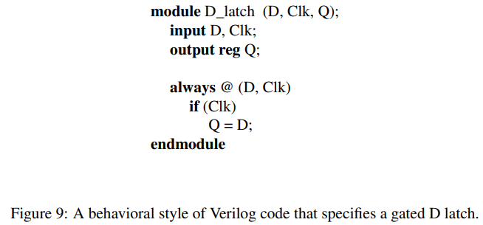

module *task_4* (

*input*  clk,

*input*  D,

*output* Q_a,

    Q_b,

    Q_c

);

*d_latch* A (

       .D  (D),

       .clk(clk),

       .Q  (Q_a)

   );

*d_flip_flop* B (

       .D  (D),

       .clk(clk),

       .Q  (Q_b)

   );

*d_flip_flop* C (

       .D  (D),

       .clk(~clk),

       .Q  (Q_c)

   );

endmodule

module *d_latch* (

*input* D,

*input* clk,

*output* reg Q

);

   always @(D, clk) if (clk) Q = D;

endmodule

module *d_flip_flop* (

*input* D,

*input* clk,

*output* reg Q

);

   always @(posedge clk) Q <= D;

endmodule

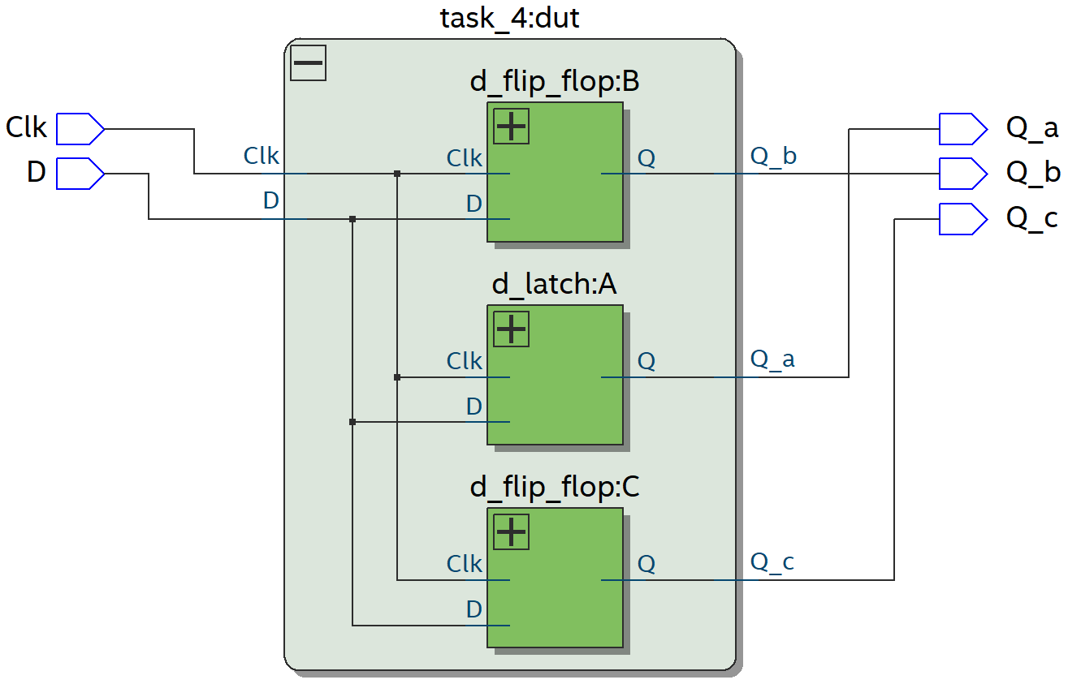

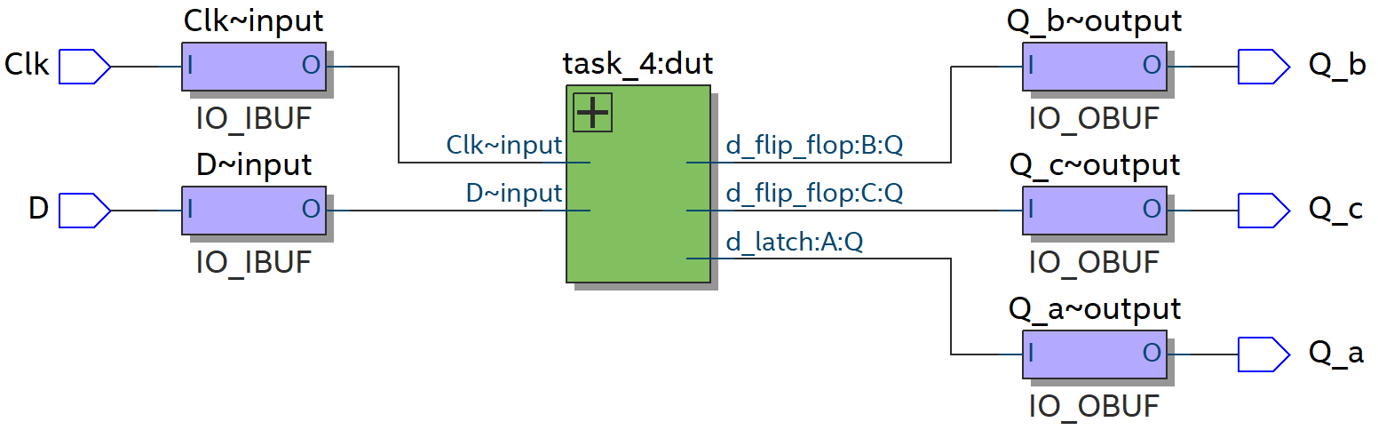

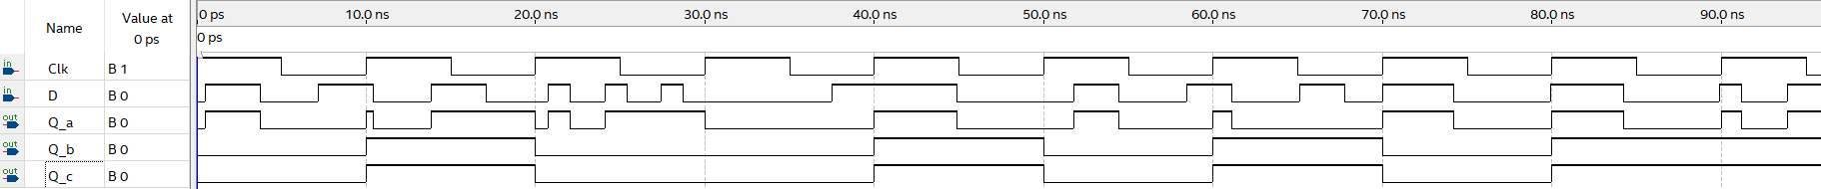

 

## Part V

We wish to display the hexadecimal value of an 8-bit number A on the two 7-segment displays HEX3 − 2. We also wish to display the hex value of an 8-bit number B on the two 7-segment displays HEX1 − 0. The values of A and B are inputs to the circuit which are provided by means of switches SW7−0. To input the values of A and B, first set the switches to the desired value of A, store these switch values in a register, and then change the switches to the desired value of B. Finally, use an adder to generate the arithmetic sum S = A + B, and display this sum on the 7-segment displays HEX5 − 4. Show the carry-out produced by the adder on LEDR[0].

1. Create a new Quartus project which will be used to implement the desired circuit on your DE-series board.
2. Write a Verilog file that provides the necessary functionality. Use KEY0 as an active-low asynchronous reset and use KEY1 as a clock input.
3. Include the necessary pin assignments for the pushbutton switches and 7-segment displays, and then compile the circuit.
4. Download the circuit onto your DE-series board and test its functionality by toggling the switches and observing the output displays.

module *task_5* (

*input* clk,

*input* select,

*input* reset,

*input* [7:0] in,

*output* [7:0] out_A,

*output* [7:0] out_B,

*output* [7:0] out,

*output* c_out

);

   wire [7:0] in_A, in_B;

*register_8b* regA (

       .in(in),

       .en(~select),

       .clk(clk),

       .reset(reset),

       .out(in_A)

   );

*register_8b* regB (

       .in(in),

       .en(select),

       .clk(clk),

       .reset(reset),

       .out(in_B)

   );

*fulladder_8b* adder (

       .a(in_A),

       .b(in_B),

       .s(out),

       .c_out(c_out)

   );

   assign out_A = in_A;

   assign out_B = in_B;

endmodule

module *fulladder_8b* (

*input* [7:0] a,

*input* [7:0] b,

*output* reg [7:0] s,

*output* reg c_out

);

   always @(*) begin

      {c_out, s} = a + b;

   end

endmodule

module *register_8b* (

*input* [7:0] in,

*input* en,

*input* clk,

*input* reset,

*output* reg [7:0] out

);

   always @(posedge clk, negedge reset) begin

      if (reset == 0) begin

         out <= 0;

      end else if (en == 1) begin

         out <= in;

      end else begin

         out <= out;

      end

   end

endmodule

module *decoder* (

*input* [3:0] in,

*output* reg [7:0] HEX

);

   always @(*) begin

      case (in)

         4'b0000: HEX <= 8'b1000000;

         4'b0001: HEX <= 8'b1111001;

         4'b0010: HEX <= 8'b0100100;

         4'b0011: HEX <= 8'b0110000;

         4'b0100: HEX <= 8'b0011001;

         4'b0101: HEX <= 8'b0010010;

         4'b0110: HEX <= 8'b0000010;

         4'b0111: HEX <= 8'b1111000;

         4'b1000: HEX <= 8'b0000000;

         4'b1001: HEX <= 8'b0010000;

         4'b1010: HEX <= 8'b0100000;

         4'b1011: HEX <= 8'b0000011;

         4'b1100: HEX <= 8'b1000110;

         4'b1101: HEX <= 8'b0100001;

         4'b1110: HEX <= 8'b0000110;

         4'b1111: HEX <= 8'b0001110;

      endcase

   end

endmodule

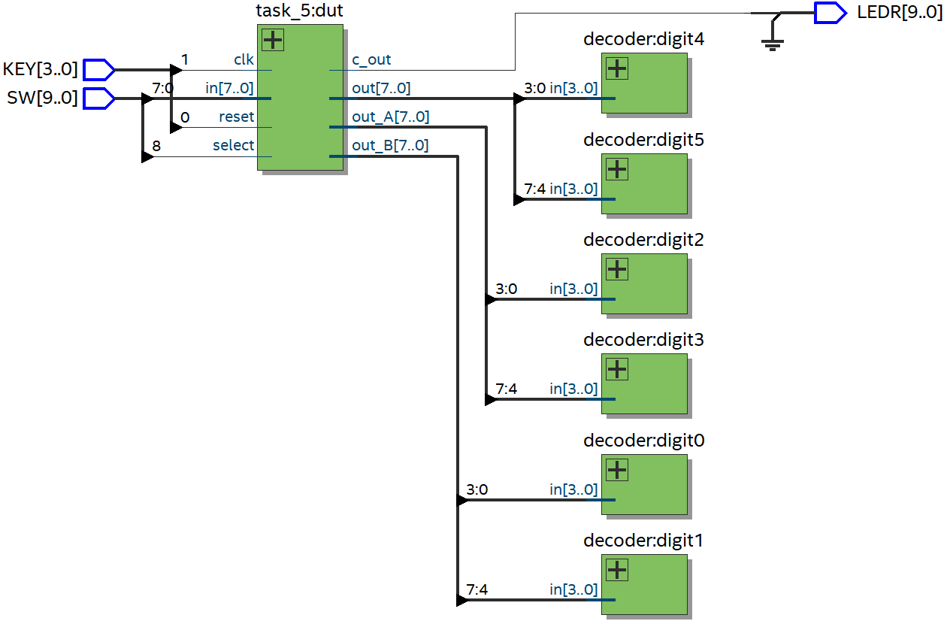

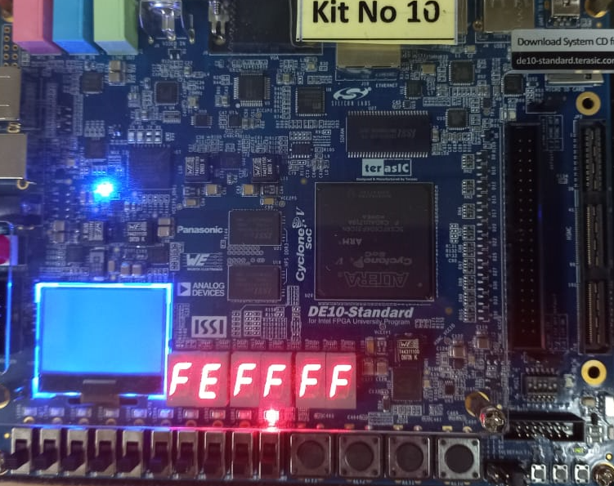 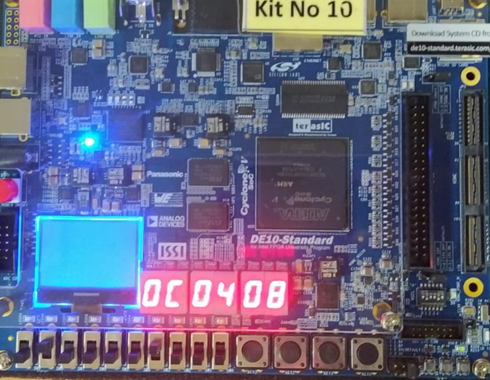

# Conclusion

Through this lab exercise, we have gained a deeper understanding of latches, flip-flops, and registers and their behavior on the DE10 FPGA board. We have observed how these basic building blocks can be combined to create more complex digital circuits that can perform sophisticated operations. We have also explored the practical applications of these circuits in digital design, including memory, counters, and state machines. By understanding the principles behind these components and their applications, we can design more efficient and effective digital systems.